Dowsing Lewes
Grace& Andrew Edgar, Eleanor Austin, Ron Puttock, Damian Walsh & Kevin Simmonds

How we dowsed Lewes
In 2024, from June to August, Lewes Dowsers Group completed our Lewes project. The objective of the project was to identify and dowse the major energy lines that currently affect the town of Lewes (in East Sussex). The phases of the project were the same as in Cardiff Project (published in Dowsing Today in April 2016).
Firstly, we discussed what we wanted to dowse and we settled on the 10 most important Energy Lines in Lewes today. We haven’t limited ourselves to any particular type of line, but chosen any line of dowsable Energy. We have specified that the lines must be important for all people living in Lewes today, not only those living on the lines and not for Group members. ‘Today’ was an aspect that we discussed and the agreement came to ‘in the year of dowsing’.
Secondly, a group of 18 Dowsers, with level of experience from basic to advanced, map-dowsed Lewes. From previous experience we made sure that everyone dowsed the same map, as different map scales make a comparison impossible or at least not very accurate. We dowsed separately at home. Next, we compared our maps and found 10 lines, which completely or partially overlapped between dowsers. Looking at the length of the line within Lewes, we found, amazingly, that 3 Lines had 100% of agreement, 5 Lines had 80-50% of agreement and 2 Lines had about 30% agreement. By ‘agreement’ we meant that 3 or more Dowsers found the line in the same place. We’ve chosen to investigate further the 6 lines with the strongest agreement.
The fourth stage was of course dowsing on site. We’ve split into the 6 teams, each for every line. The teams dowsed between 8 to 14 points on their line, in some cases the whole length of the line. We followed a written procedure as not to forget what we’re dowsing for. For the next 3 month the teams were relentlessly exploring the Lines, with some making up to 7 visits to the Line. Finally, the whole Group dowsed 2 Lines which we felt were the most interesting and most clear in terms of strength and location.
On site, our task was 1) Find the line dowsed on the map. This really was the main point of this exercise for our relatively new Group. 2) Measure direction of flow, if there was any, 3) Measure its width, 4) Measure its strength, 5) People also were very keen on finding/feeling the feminine /masculine quality of the line - this came very easily to all of us. Maybe next year we’ll venture to bigger things such as depth, height and detailed width of the line, also lunar, solar, planetary alignments, and changing width according to the time of the day or the moon phase or number of swallows passing above (some of it is a joke!).
As the last stage, Grace asked teams to try to feel the character of their line, either standing on it or remotely from home, so we did a short meditation about the line.
Results of Dowsing Lewes
Lewes is a small, quirky, historic town, where several important historic events happened, right? So you’d expect the lines should pay attention to these. Alas, the lines only paid attention to one historical event, this will be explained and discussed further.
Interestingly, unlike in the Cardiff Project, we didn’t find any of those negative, choking, stinking lines, either with map-dowsing or dowsing on site. This will be discussed at the end of the article.
I will now describe each of our 6 lovely lines – all positive and most of them glowing with pleasure when they run freely through Lewes.

Line WL1 – Effect of the Summer Storm
The team discovered that it dowsed as an Energy Line not a Water Line (it was found a Water line during map-dowsing) and it frequently seemed to be slightly South of the map-dowsed line. It runs in South Lewes and the strength was found variable, from +5 to +10, on the usual BSD scale. The energy of the Line has temporarily doubled after the Summer storm, the strength to +8 and the width to 12m! The character of the Line was felt as gentle and female. The Line seemed to be 'passing through' rather than having a particular impact on the town, She keeps to the fields in Lewes and runs through the higher, open landscape of South Downs outside of Lewes. She doesn't touch any significant areas of Lewes past or present, despite passing close by, like football stadium or Trinity Church. The team found it striking how they found the line position the same at crossing points. (picture 1).
Line WL2 – Effect of Railway Line
She runs in North of town with very variable strength and width: +4 /+7 and 4/5m, she’s a female line and she’s a line of underground water. She’s stronger and wider in happy places – on the outskirts of town, rural areas or quiet residential areas with big houses and she’s narrower and weaker along busy roads. Interestingly, the Line looses 50% of strength and width as She is dowsed on a foot bridge above the railway line in Pells area of ponds (pictures 2&3). The team felt that WL2 is a very old line, She was here before Lewes. She’s a powerful line, stronger out of town; She’s like an elemental force: like oceans, woods, air. WL2 is refreshing to people, like meditation or deep rest, and to animals and to the landscape. She’s independent of people – people only affect 5% of her strength. Three team members were able to feel the Line without instruments.
Line EE4 – Effect of the Battle of Lewes
This energy Line runs happily in North of Lewes, and it’s strength is usually +6/+8, but it’s variable in width. However we noticed a big change at the last two dowsed points at Race Hill, bottom of Offham Hill (picture 3) - the strength went down from +7 to +3 and the width from 6m to 2m, within the distance of a mile of open field. That was totally unexpected and prompted us to ask the locals what happened there: then we discovered the Battle of Lewes, 1264 AD! B of L was a very bloody battle between the barons, led by De Montford, with 5,000 men and the King Henry III, with 10,000 men; the losses were over 3,000 people. For comparison, the population of Lewes at this time was between 1200 and 1500 people. Henry was forced to launch an infantry attack up Offham Hill (just above Race Hill) where he was defeated by the barons' men. The royalists fled back to the castle and priory and the King was forced to sign the Mise of Lewes, ceding many of his powers to de Montfort. During the battle, Lewes was burnt and many of the civilian population slaughtered. This traumatic event happened 800 years ago and is not in the living memory, but the Line remembered! We couldn’t miss the opportunity to dowse this event. The Group went to the Race Hill where all of us found places where people were killed or injured during this battle, with highly unpleasant energies. We were able to map the extend of the Battle of Lewes on Race Hill.
Line EE1 – Cleansing and Recycling Energies
This Line runs from the South, but sharply turns West at the corner with the modern prison, modern hospital and sites of a medieval hospital and an ‘infectious hospital’ were placed. The strength and width are not variable, of +7 and 3m. Here we came across another curious phenomenon in the mentioned sharp corner; here the Line seems to produce several lines, which run parallel to the Line but in the opposite direction, creating a loop, before coming back to join the Line. We knew that this place was another main location of the Battle of Lewes (see EE4). The investigating team felt that the loop of lines has a function of cleaning or recycling the heavy energy. So the complex network of lines serves to balance the emotional energies of this south-western part of Lewes. The negative emotions arise from the prison, hospitals and perhaps a memory of the Battle of Lewes. These energies were circulated through the Line and cleansed and replaced by the positive energy and emotion generated on the top of Offham Hill (which is also the site of a Neolithic causewayed enclosure, so perhaps itself always a site of healing) (picture 5).
Line EE5 – Avoiding Historic Places
We spend a lot of time on this Line, because it runs through the centre of Lewes and it’s curious as well. The strength was stable +3/+4 and the width 7/10m and it’s character is feminine, wispy, elusive and gentle. Curiosity lay in the fact that the Line avoids most historic places it passed! But She did go through the Lewes castle grounds. She runs close to, but avoided, 1) the Martyrs Memorial on the outskirts of Lewes, dedicated to 17 Protestant Martyrs who died during the reign of Mary Tudor, 2) the commemorative plaque for these Martyrs at the Lewes Town Hall, close by to where the Martyrs were burned 3) the War Monument in the centre of Lewes, 4) St Thomas Becket church 5) also the route of the Bonfire Night Procession, for which Lewes is famous. The procession runs, with interruptions, since 1853, initially as a commemoration of the Gun Powder plot (1605), later with commemorations of Protestant martyrs and other historical events and personas, with a contemporary person thrown in (in 2022 it was Liz Truss and the lettuce!). Seven Bonfire Societies are parading, with around 1000 members. It is the biggest procession in the country! Note if you’re planning to see it - recently, the council want to keep it local, so there are no trains after midday on the day and they resume the next day (http://www.lewesbonfirecouncil.org.uk/index.html). You’d think that the Line would be interested in these events as it passes close by, but no, it isn’t.
Additionally, EE5 Line ‘spouts out’ and creates a pool of energy, covering the old parks of Baxters Field and The Paddock. These places were difficult to dowse: a nice, well-behaved, stable Line, suddenly became many lines and dowsers found the ‘tributaries’ of the Line in different places! This was very trying to the dowsers’ confidence but we investigated further and came to an agreement. The pool of energy created by the Line in the centre of Lewes is very pleasant and we’ve a feeling that the Line somehow protected these ancient parks from development since medieval times. The place where the Line splits is very potent in Earth Energies: +7/+8. See picture with the pool of energy created by EE5 (pictures 6) and a place related to Bonfire Procession (picture 7).
Line EE8 – Touching Places of Worship and Healing
This female line, being shorter than other lines, runs in the Southern Lewes and She’s whimsical as She has lots of turns and twists and coming back on itself. She is stable, with strength of +4 and width 4/5m. She touches places of worship: the chapel that once was on Chapel Hill, the Quaker House, possibly another chapel North of Quaker House, the Great Church that stood inside the famous Lewes Priory, now in ruins (it was also a healing centre) and the Unity Centre (new-age healing place). But it doesn’t touch Thomas Becket and All Saints churches (last one now a community centre).
As the line passes through the painted doorway of the Friar in Friars Walk and through a door numbered 1& ½ (remember ‘Harry Potter’, platform 9 & ¾ ?) - the team got the impression that the Line was playful and had a sense of humour! (picture 7). The team also felt the Line was neither happy nor unhappy, but She drew away unhappiness from all around her - the land, the air, and all living things – She was about movement; She runs the way between energy sources for cleansing and recharging.

Lessons Learned
- All our teams found the 6 lines on site. And in the same place as identified through map dowsing. (with a small exception of WL1, parts of it run few yards South of map-dowsed line). And the direction of all 6 lines on site agreed with that in map-dowsing. This was the main aim of the project and it was achieved. The Group now has an experience that map-dowsing works.
- The Lines are stronger and wider in beautiful, green places & close to the river; and weaker and narrower in not very nice surroundings and while running alongside or crossing the roads. Lines tend to avoid roads and their strength and width were affected negatively by crossing roads or railway lines. The energy increased after a Summer storm.
- It’s important to concentrate on the particular line we’re dowsing; often there were several lines in one location and while dowsing one line we could easily transfer to dowsing another line.
- Although map-dowsing is very helpful, we always should give preference to results found on site over and above the map dowsing results.
- Dowsing in the urban environment and on (sometimes very) narrow and winding streets in Lewes added a level of difficulty, as often the line was blocked by buildings, cars, passers-by; so small parts of lines were not dowsable.
- We often encounter people interested in Dowsing; it’s an individual choice how much to talk to them and support their dowsing/spiritual interests; and how to balance this with the time we intend to spend on Dowsing.
The teams worked very hard and we have had several great dowsing outings, some surprisingly early on a Sunday morning, to avoid traffic. We have many great memories while dowsing Lewes and we’ve taken many beautiful pictures.

Discussion
Why do the Lines avoid historic events, apart from the Battle of Lewes? What comes to mind, is that what is important for people, may not necessarily be important for the energy lines. Especially, if the lines were old or ancient, and present before Lewes was built. Also, the influence of human events can be affected by the events’ strength – surely killing thousands in the Battle of Lewes and treating hundreds of victims of disease and injury in hospitals, should have greater effect than deaths of 17 Protestant martyrs, not undermining their suffering and importance. So maybe the Lines give us a sense of scale. Also an interesting idea was brought up that the character of 6 Lines – 5 of them were definitely female – may not agree with prominent Yang features, such as war monuments, or churches – Christian churches are the product of male culture. Gary Biltcliffe and Caroline Hoare (The Spine of Albion) have found a similar result as the Elen line tries to avoid the Earl of Yarborough Monument on the Isle of Wight.
We were also pondering the lack of negative lines between ‘the most important lines for Lewes’. Grace and Andrew remember negative lines in Cardiff and some of them were really strong to the point of making dowsers feel unwell. We trust in the abilities of our Lewes Group, which in fact is similar to Cardiff Group, and also our procedure was identical. We don’t believe that 18, sometimes very experienced and talented dowsers, would have missed an important line. Of course there are some negative lines in Lewes; but maybe they’re not important enough to the whole of Lewes to show themselves in our research.
We invite you all to consider these points, share similar experiences and any reflections you may have about our Lewes Project. Let us know.

Picture 1 – Line WL1 does not go through Trinity church.
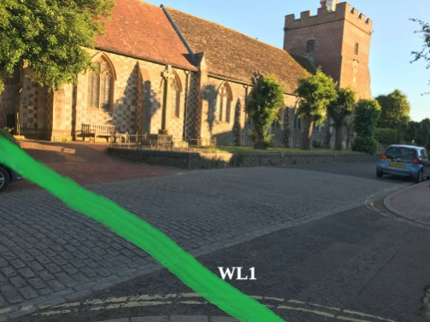

Pictures 2 & 3 Line WL2 (on the ground) measured above the railway line
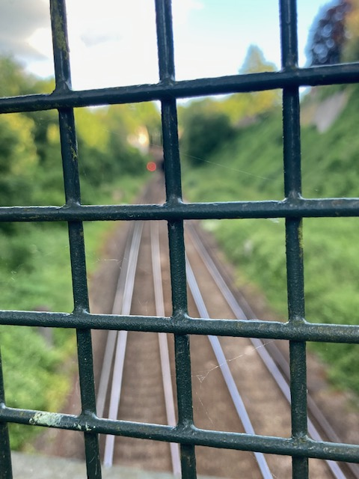
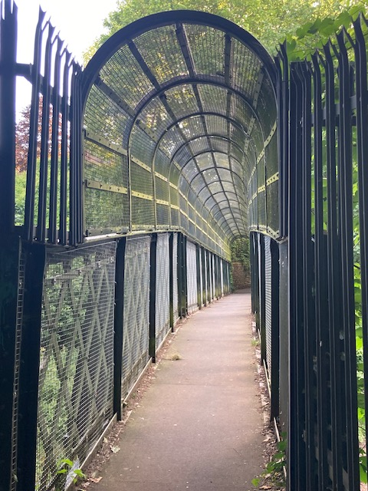

Picture 4 Line EE4, Beginning of Race Hill
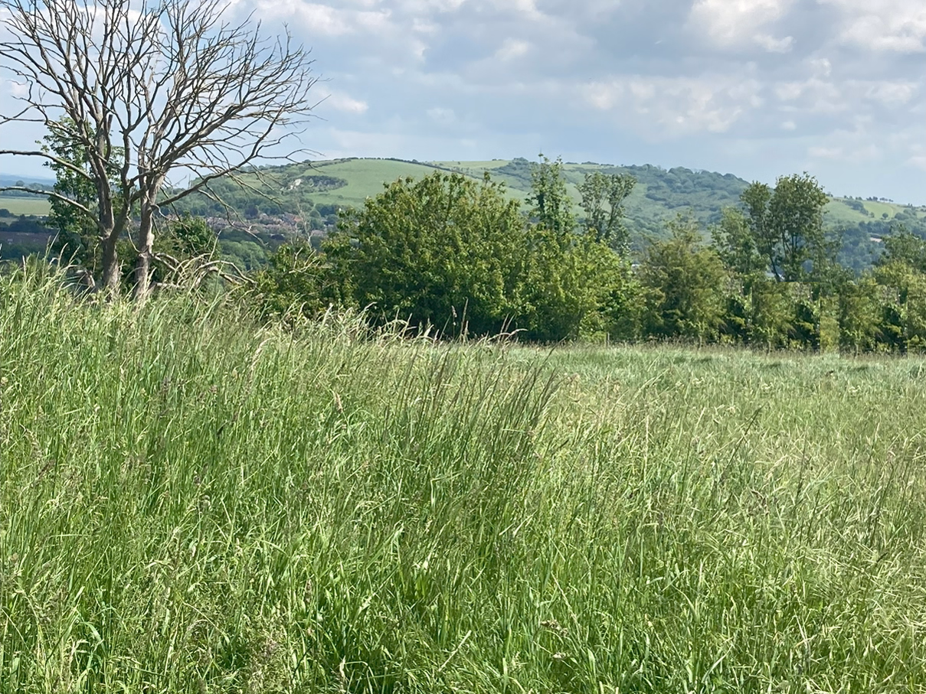

Picture 5 Line EE1, Cleansing the energies

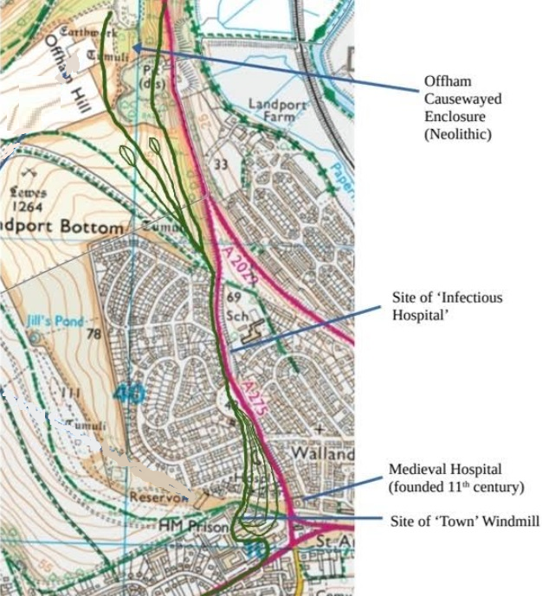
Picture 5 Line EE5 splits creating energy field.
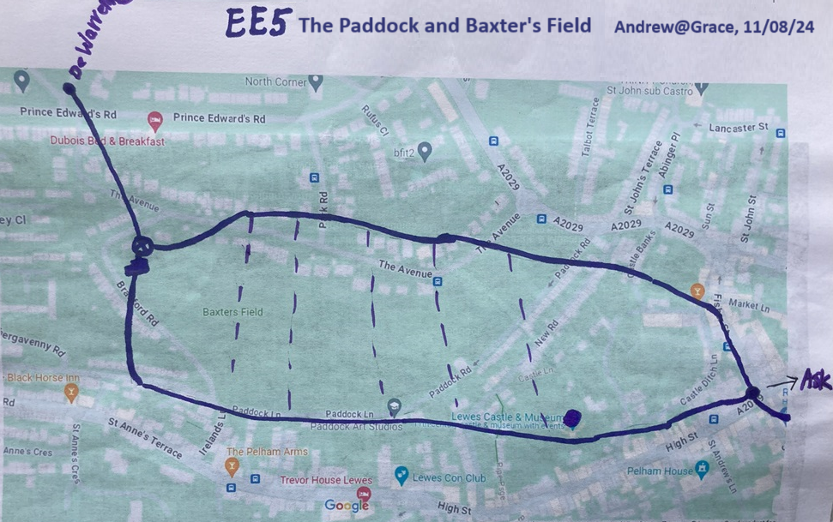

Picture 6 EE5 splits creating an energy field
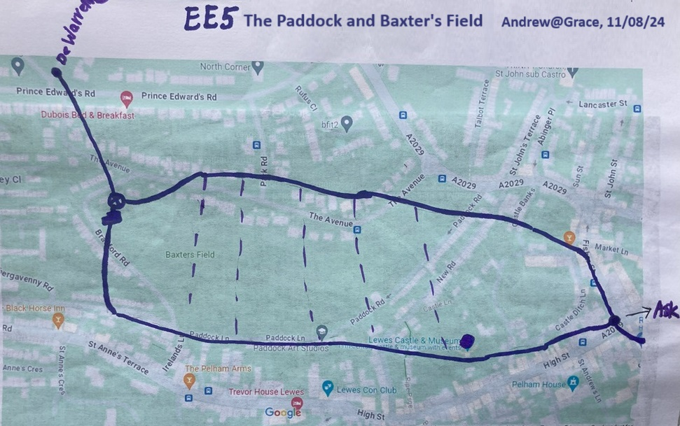

Picture 7 EE5 and EE8 form a small node at the junction of Cliffe High Street and Chapel Hill – and the leftover fireworks from Lewes Bonfire Night are discharged here, probably energising both lines.
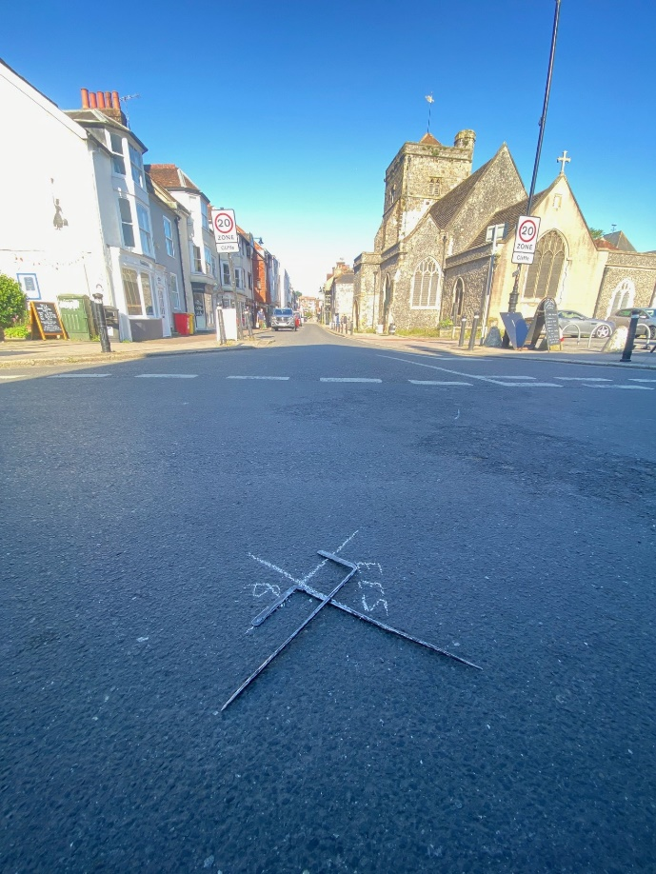
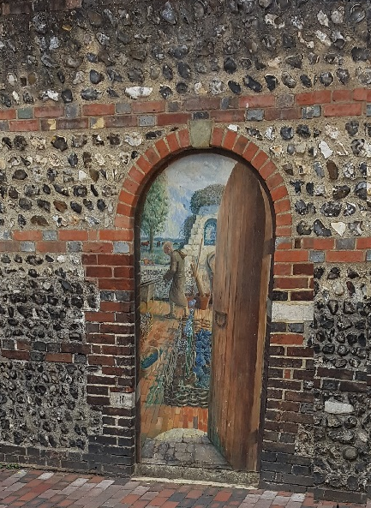

Picture 8 Line EE8, painted ‘door’ in Friars Walk

.
Picture 9 Lewes Project, final outcome, Lines after dowsing on site
